LATTA GENEALOGY NEWSLETTER

Issue 66, Pages 14-17 Fall 2018

MARY BELLE LATTA
May 23, 1874 - June 30, 1950
Monroe County, Ohio

By Betty Jane (Latta) Kitchen, kitchen2new@earthlink.net

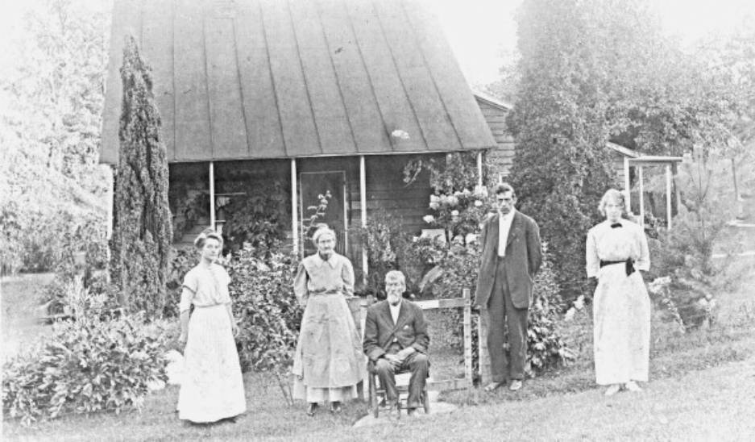

[pictured left to right]

Mary (Burris) Latta, Mary Jane (Morris) Latta, John Copeland Latta, Thomas Leroy Latta, and Mary Belle Latta
in front of Mary “Jane” and John's home
Malaga Twp., Monroe Co., Ohio
ca 1900

Mary Belle Latta, the daughter of John Copeland Latta and Mary Jane (Morris) Latta is listed in Branch 17 of the Latta families.
I inherited a newspaper clipping published in either the Monroe Gazette, Woodsfield, Ohio, or The Spirit of Democracy, Woodsfield, Ohio. Although there is no date on this clipping, I think it was in honor of Mary Belle Latta's 2lst birthday in 1895, because when it mentions all in attendance it includes Mr. and Mrs. T. L. Latta, and that couple was married in October, 1894. It also includes Miss Lou Latta so her sister was not yet married and neither was her cousin Anna Latta who married in 1897. It is interesting to note the type of entertainment, the kinds of presents that were given in 1895 (like dress patterns, for a particular color dress, not the dress itself), and the many people in attendance that are recognized in Monroe County, Ohio, genealogy. Below is the article:

"One of the most pleasant social events of the season was the surprise birthday party given by about one hundred of the young people to Miss Mary Latta, on May 25th. The surprise was complete. The beginning of the evening was spent in social chat, interspersed with instrumental music by J.T. and sister and brother,* after which came the ice cream supper (with cake and lemonade to prevent taking cold.) During supper J.T. Latta* gave us some fine comic songs, with banjo accompaniment. The following are some of the presents: Mr. and Mrs. J.C. Latta,** black serge dress pattern; F.F. Haren, silkaline apron; Albert Yunkus, fancy hair-pin and silk mitts; V.T. Sluser, silk mitts; Miss Clara Kremer, fancy hair-pin; C.E. Peters, bottle of cologne; Miss Laura Vincent, pair of hose; Miss Anna Latta,*** cracker dish; Miss Sallie Christman, sugar bowl; Mrs. Alice Carpenter, fruit dish; Miss Belle**** Morris, individual salt dish; Davy Latta,* fancy hair-pin; Miss Mollie Ruble, fruit dish; Miss Lydia Morris,**** butter dish; Miss Julia Hardesty, two handkerchiefs; Greg. Haren, pair of towels; J.T. Latta,* silk handkerchief; Clem Standt, side combs and silk handkerchief; Mr. and Mrs. T.L. Latta,**** water pitcher; Miss Anna Claus, handkerchief; John Christman, 50 centst [sic—cents]; Wm. Wall, 25 cents; Miss Lou Latta,* lamp; Miss Katie Christman, silk handkerchief; Miss Rosa Burkhart, apron; H.J. Landfeld [sic—Landefeld], 25c; George Christman, 25c; Misses Tillie and Louisa Claus, apron; Gus Standt, 50c; Miss Emma Steel, 25c; J.W. Ruble, fruit dish; Lewis Landefeld, 25c; Geo. Christman, silk handkerchief; Miss Ida Haren, apron; Miss Lou Keller, apron; Adam Weiscent, pair gloves; Miss Sadie Burris, white shirt waist; Clem Weiscent, red blouse pattern; Mr. and Mrs. D.W. Latta,*** tea set and silk handkerchief; Fred Christman, bottle of perfume in casket; Ray Murray, silk scarf; Ben A. Haren, fancy chair tidy. Several other presents were received without names. After supper was over, a few enjoyable games were played, after which we all went home wishing Miss Mary 'many happy returns of the day' or rather evening."

My Notes:
* J.T. Latta was her brother, John Tilden Latta. He played the violin, wrote poetry and songs. He married Mary Udell, and they became missionaries in Burma. All six of their children were born there.
Her sister Louisa Ellen played a pump organ. She married Chris Matz and they raised their family of five children in Ashland, Ohio.
Her brother Davy, my grandfather David Wilson Latta, played the banjo. He married Effie Jane Schaub. They raised their five children in Canton, Ohio. He became a vice president for Hercules Motors and was instrumental in their contribution to the World War II effort.
** Mr. and Mrs. J. C. Latta are her parents, John Copeland Latta and his wife Mary “Jane” (Morris) Latta. When Mary Jane's father Henry Gustler Morris died, they bought his home and the land he purchased in 1837 in Malaga Twp., Monroe Co., Ohio, and raised their family there. John and Mary Jane had eight children.

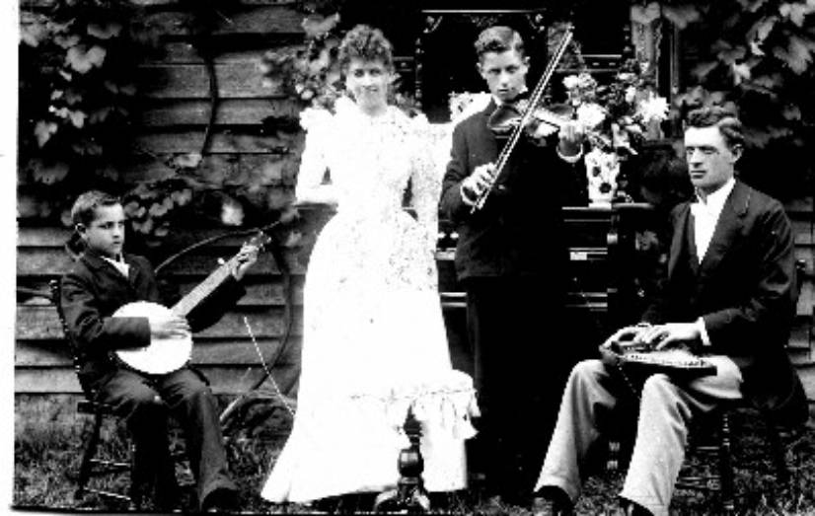

[left to right]

David Wilson Latta (1881-1956) and his banjo
Louisa Ellen (Latta) Matz (1871-1949) in front of her organ
John Tilden Latta (1876-1950) and his violin
Thomas Leroy Latta (1866-1925) and his autoharp
in front of the John C. and Mary Jane (Morris) Latta home
Malaga Twp., Monroe County, Ohio
ca 1891

*** Anna Latta and D.W. Latta are her cousins, children of Samuel Seymore Latta and his wife Elizabeth Hannah Okey. Anna Belle married William Forest Turner. They had seven children and spent most of their life in Monroe County, Ohio. David Weir Latta married Rachel P. Snodgrass. He farmed in Wayne Twp., Monroe Co., Ohio his entire life.
**** T.L. Latta was her brother, Thomas Leroy Latta. He and his wife Mary (Burris) Latta were both teachers. They had one child, Thomas Burris Latta, who was born and died in 1896. A photo of T.L. and the class of 1894 at Fox Hollow School, located close to Miltonsburg in Monroe County, is pictured at the lattalinkedlineage web site:
http://freepages.genealogy.rootsweb.ancestry.com/~lattalinkedlineage/Fox_Hollow.htm [LATER NOTE TO THIS: The rootsweb site has not yet been able to be updated since ancestry.com did “maintenance” in November, 2017. As of 2019, this photo can be seen at the current site maintained by Richard Harrington: https://reharr.github.io/MCGen/Fox_Hollow.htm]
In that photo Thomas Leroy Latta is the teacher and the students pictured include his brothers John and David, and his cousins Belle (Susanna aka Anna "Belle") and Jennie Morris. Belle first married Charles Frederick Stauch. They had three children. He died in 1924 from tuberculosis. She later married Henry Elmer Ullom. After he passed she thirdly married George Washington Piatt. Jennie married James "Miley" Carpenter.
My Aunt Jan (Janedith Ellen Latta, 1913-2006) told me that her Aunt Mary Belle had auburn hair, brown with red overtones. (Perhaps that is why she received so many hair pins at the party?) Mary Belle never married. She cared for her parents at the family home until they passed. That was not an easy task for a woman in the hills of Monroe County. She was a good shot.
This is the gist of a story told to me and my husband Don Kitchen by Frank Christman when we were visiting with him, his wife Josephine, and son John on October 12, 1997. The Christmans moved into their home on Miltonsburg-Calais Road in 1946 and granted the Latta descendants access to the land-locked Latta homestead adjacent to the Christman property ever since. My cousin Don Latta and I now own this property. It is about a 50-minute walk from the Christman home. Not an easy walk. The lane used to deliver mail is no longer there so walking with one leg always higher than the other (thanks to the hilly terrain) and fighting the floribunda rose thorns and other overgrowths and fallen trees do make it difficult. There no longer are any buildings left standing.
Our neighbor in Twinsburg, Ohio, Oscar Kress, said he was born in 1925 and grew up with Frank so I figure this story took place about 1938-1940. Aunt Mary Belle was no longer living there when the Christmans moved into the dairy farm in 1946. Pre-1946 the Harens lived there, and the Christmans lived down the road.
And now the story:
Frank and his older brother Vernon had been practicing with their 22's, and now that they were teenagers they figured they were getting pretty darn good. So one day they decided to challenge that old lady who lived up the holler. Everyone talked about how good a shot she was. (Oscar Kress said nobody messed around her place, that he was afraid to hunt on her property.) So Vernon and Frank hiked up the holler to show her a thing or two. Mary Belle said okay, she'd do some shooting with them. Vernon hammered a nail into a tree, and they stepped off 50 paces. Vernon shot first. His shot barely missed the nailhead, a little to the right. Frank was next. His shot was close, but a little to the left. The only one still to shoot was Mary Belle. She took aim and hit that nail right on the head. She went back into her cabin, and the boys hung their heads in shame as they traipsed back down the holler. How could that old lady have beaten them?
Frank also said she had beautiful flowers all around her place.

OBITUARY:
Latta, Mary Latta
Source: The Cambridge [Ohio] Daily Jeffersonian; Saturday, 1 Jul 1950
Mary Latta, 76, died Friday afternoon in the Heskett Rest Home, Cambridge, where she had resided for several weeks. She was born May 23, 1874 near Calias [sic--Calais], and spent the greater part of her life there. She was the daughter of John and Mary Morris Latta.
Surviving are a brother, David Latta of Canton and several nieces and nephews.
The body was taken to the Eberle Funeral Home and will remain there for services Sunday at 2 p.m. Burial will be in the Calias [sic-Calais] Cemetery.

